**Designing For Virtual Environments**

**Group Project**



**VR Shoe Store**

Eoin Gallinagh – 17430126

Liam Aspell – 17300046

Student Name – Student Number

Student Name – Student Number

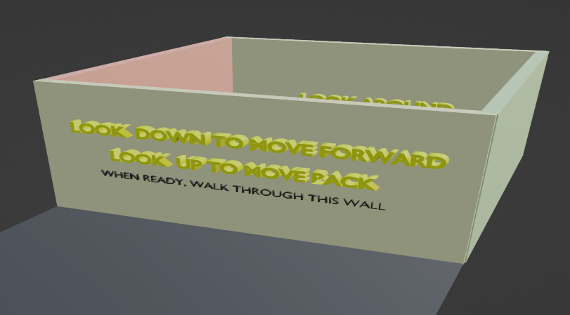Student Name – Student Number

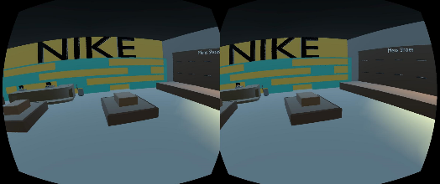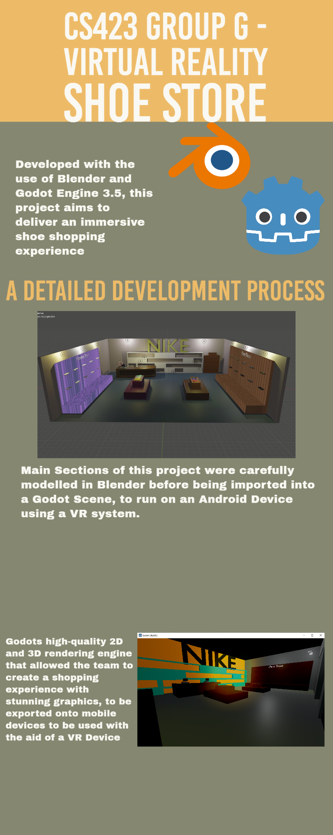**Infographic**

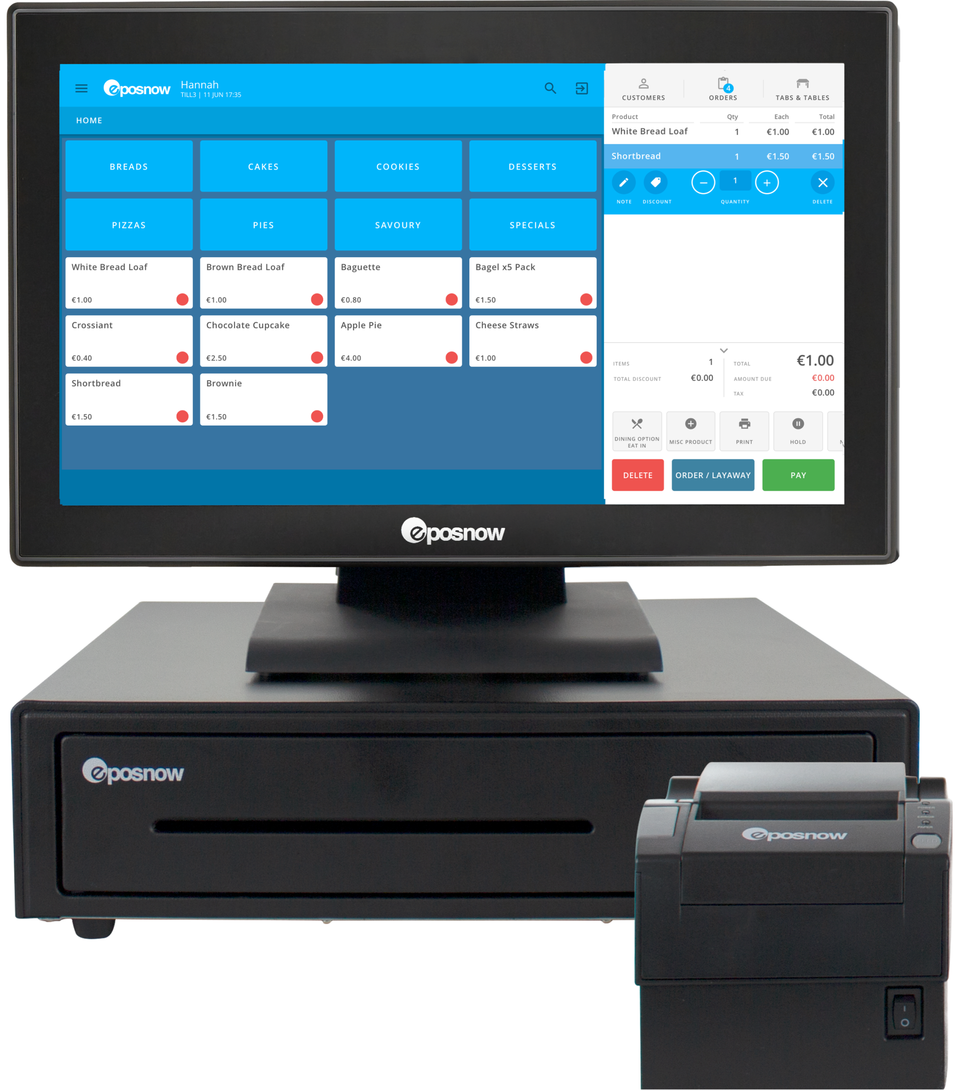Every store requires a minimum of one cash register to function. Cash register designs were inspired by online images, such as the one referenced. Subsequently, the design was replicated and modified slightly to represent both an open and closed till for added versatility.

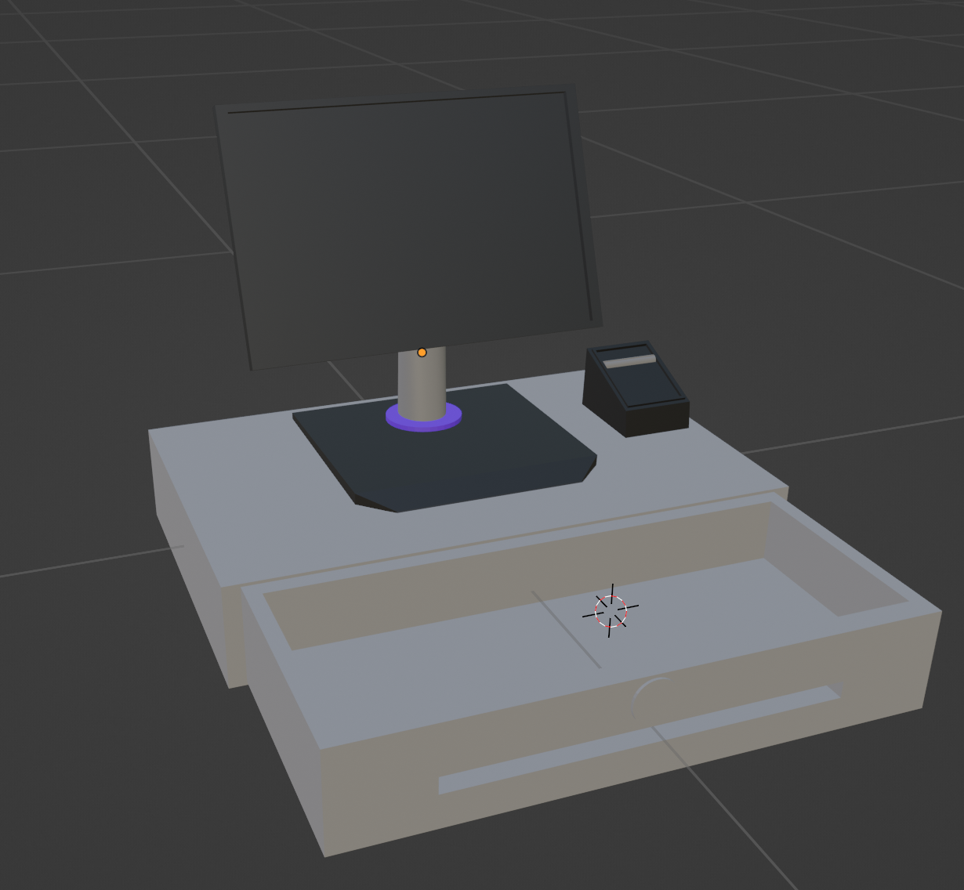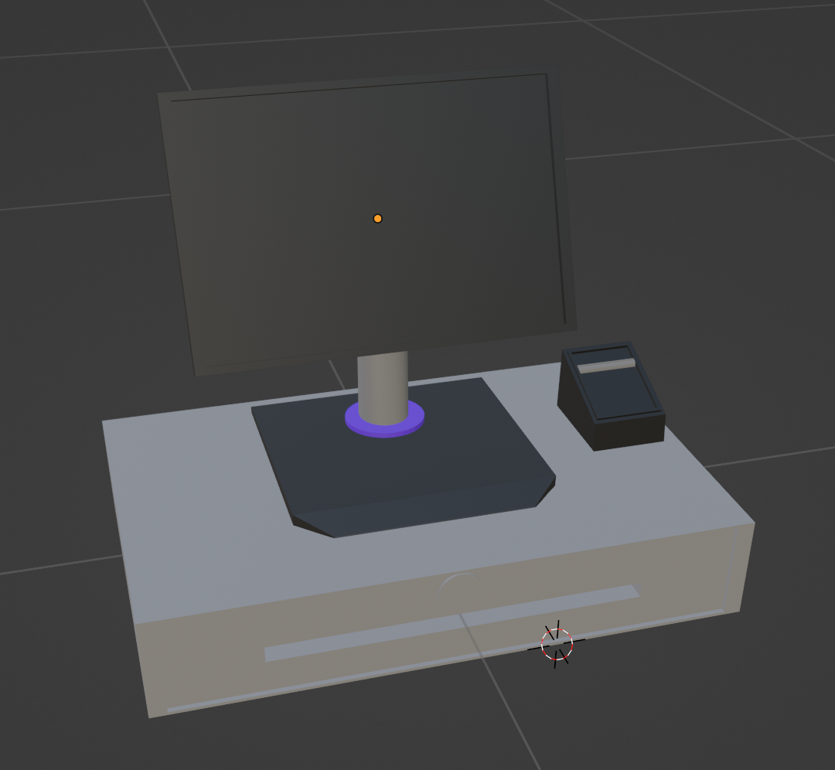

These cash registers were positioned next to a conventionally designed counter and waste bin.

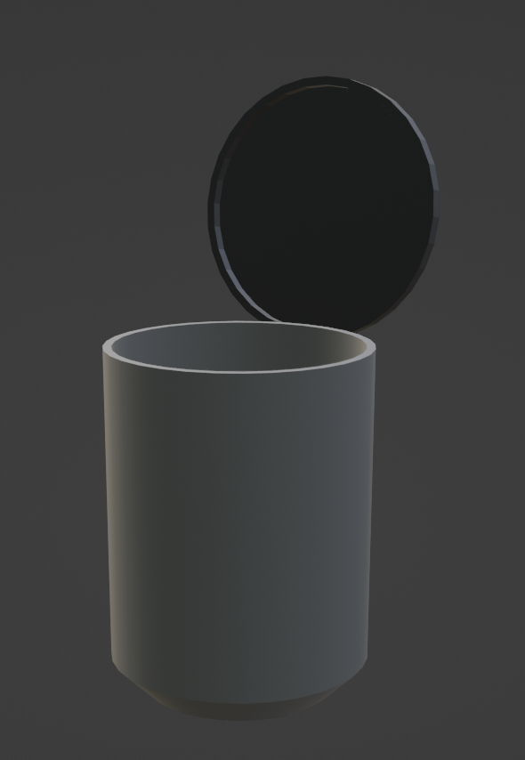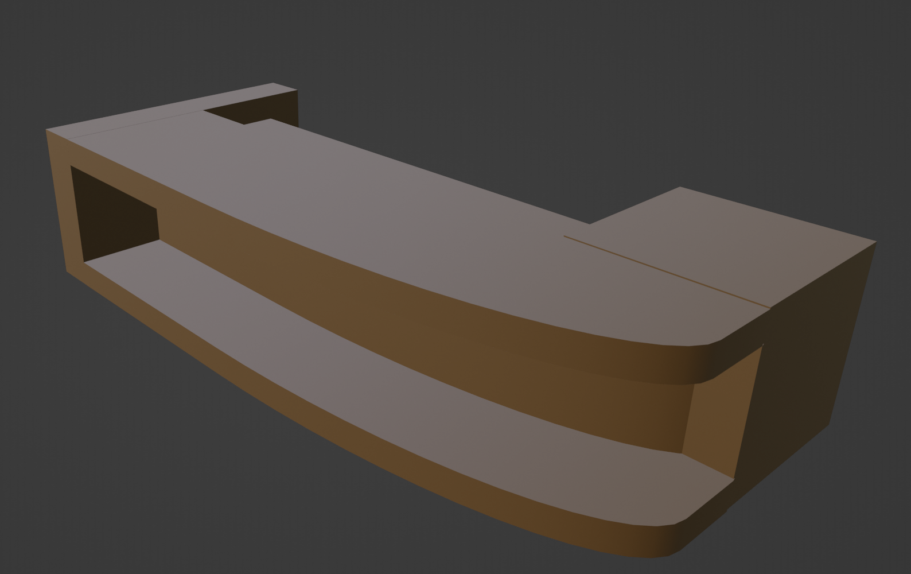

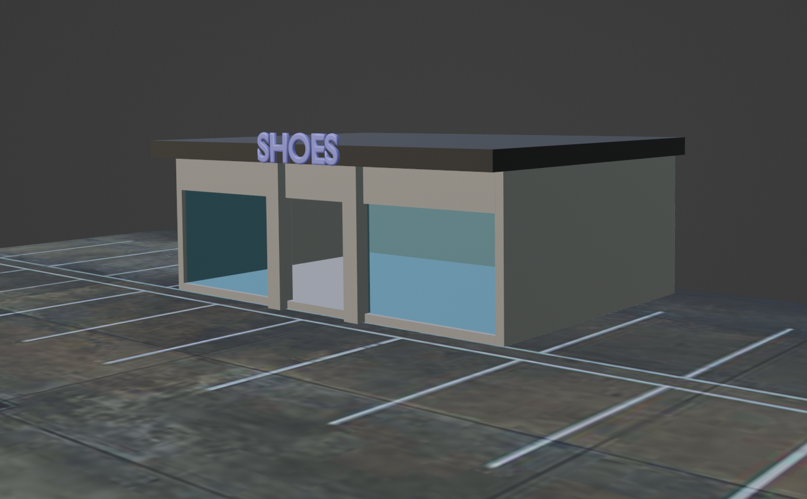

The exterior of the premises featured a minimalist design, aiming to keep the focus on the interior shopping experience. Although, starting in a spacious parking lot at a distance from the store, users would have the opportunity to familiarize themselves with the controls and navigation, ensuring a smooth and effortless traversal of the scene upon reaching the store.

The primary purpose of the main menu is to provide players with an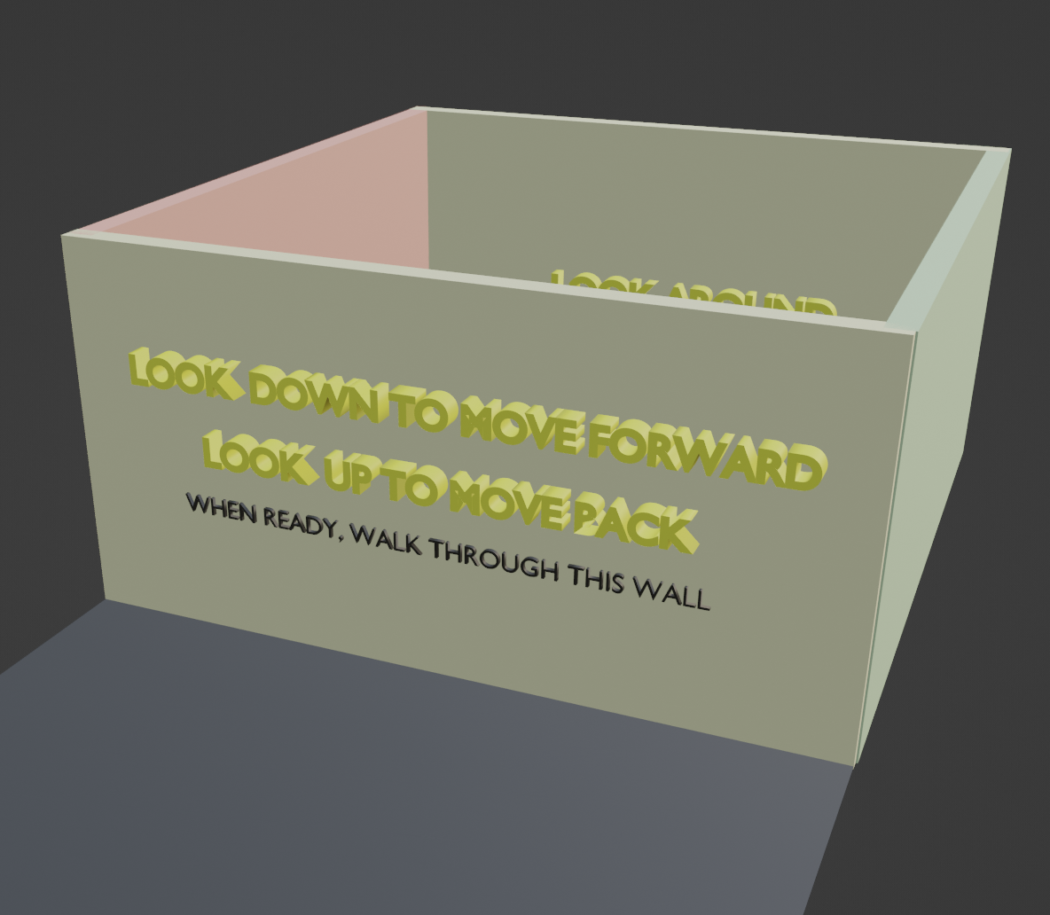 opportunity to familiarise themselves with the controls of their character's movement. The walls in the menu function as instructional aids, demonstrating how to move around. Once the player is comfortable with the controls, they can choose to exit the game or start playing by walking through the wall of their choice. This functionality is achieved through the implementation of areas and collision detection for both the walls and the player.

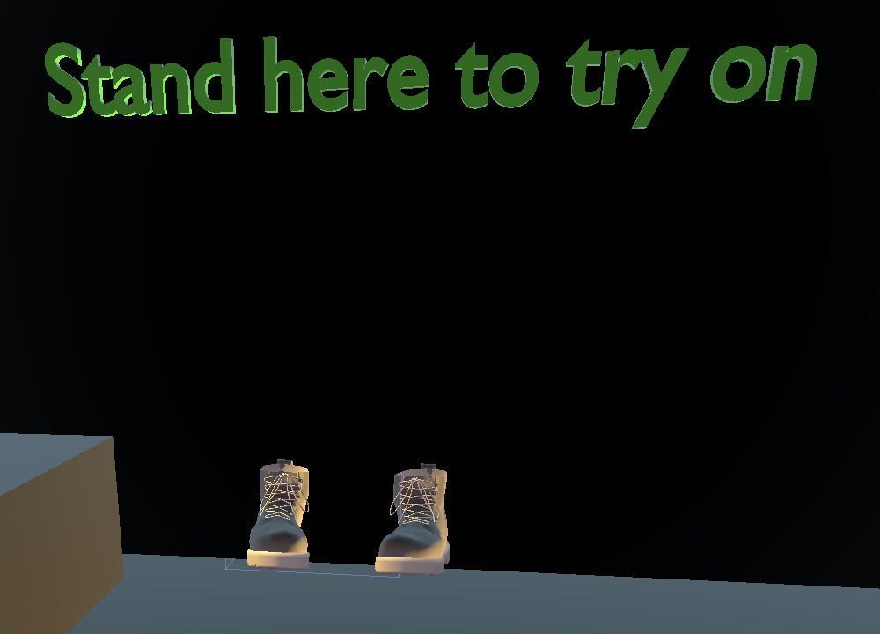

A similar technique is also implemented within the main game, where the user has the ability to “Try on ” a pair of shoes. By incorporating collision detection with area_entered again, the players movement speed is increased twofold to demonstrate the benefits of wearing the new shoes.

Ahmed Section

Syeds Section

**Some extra models to create detail.**

To combine the tasks of practicing modelling in blender to ‘warm up’ for the project, as well as creating detail in the shop scene, a selection of background items was modelled from scratch in blender. Two of these items were the lampposts that are present near the building, and the CCTV cameras which are hanging on the walls of the shopfloor. Models such as these help to create realism to boost levels of immersion.

**Designing the Shop’s Shoe Display Areas.**

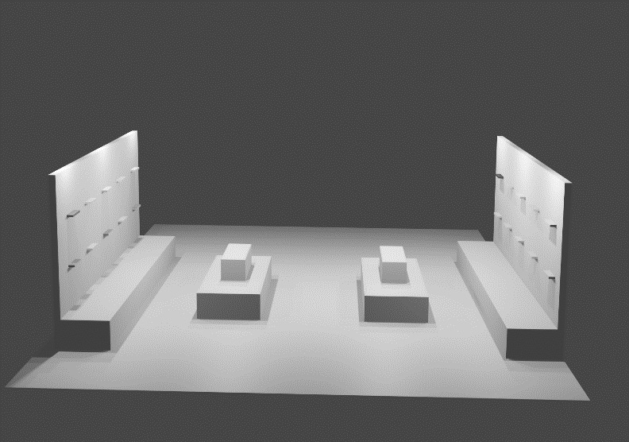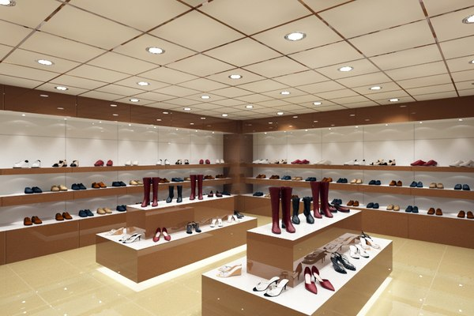The design of the shop was inspired largely by shop designs found online. One such inspiration is contained in the figure below. A scene was developed containing a shoe display wall and a display island. The approach is to have a section both for women and men’s shoes, so the symmetry seen in the model figure below will be split men and women’s sections symmetrically. The wall display units have small shoe holders typically seen in many shoe stores.

**Extra Feature – Shop Music.**

The addition of shop music into the VR environment helps to set the tone within the scene, which enhances the users overall experience interacting with the environment. The music in this scene enhances immersion by stimulating the sense of hearing, which is an important feature of virtual environments. Royalty free music was sourced and placed in the environment using an AudioStreamPlayer node. Overall, music can significantly impact the atmosphere and experience of the shop environment, creating a more engaging and memorable experience for visitors.

Dara Section